

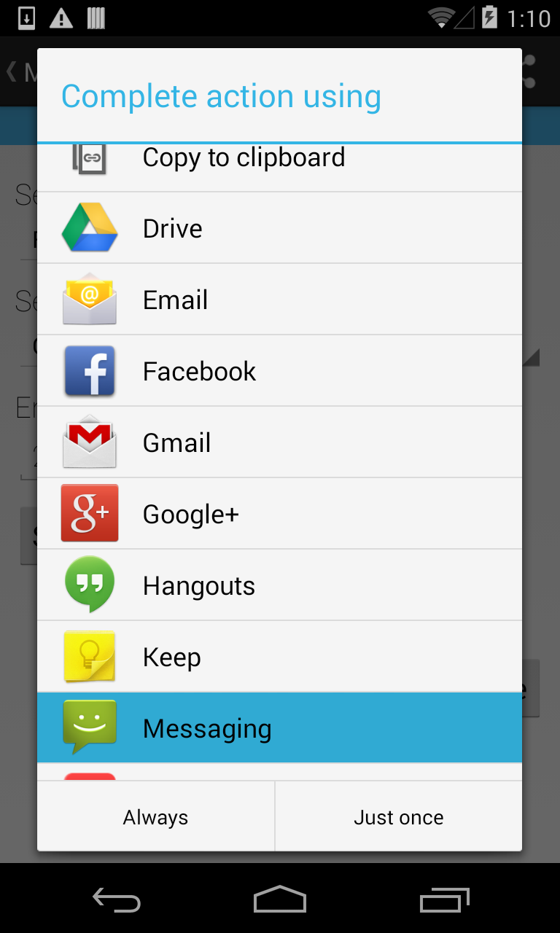

4

2

Progression Summary



Visual Progression (if applicable)

Fill out one form per feature (not activity). In the Visual Progress pane, try and outline any progress you will have made to features that affect the visual display of the app - UI Views, Navigation Controls, etc. Don’t show the entire screen (unless applicable), concentrate on the feature.

Expected Functionality



The user will be able to share the Pokémon that they’ve captured. When the user taps on the share button, there will be options for the user to choose how they want to share their captured Pokémon.

Details & Status

AddNew

Share

0

Activity

Feature

Est. Hours

Completed

0

Actual

12/11/2013

Hours

Hours

Hours

Hours

Component

Component

Component

Component

Components

Changes & Outcomes



The most difficult part was making sure the data displayed properly. I also wanted to be sure that the user would have a number of options to share their captured Pokémon.

Share Function

2



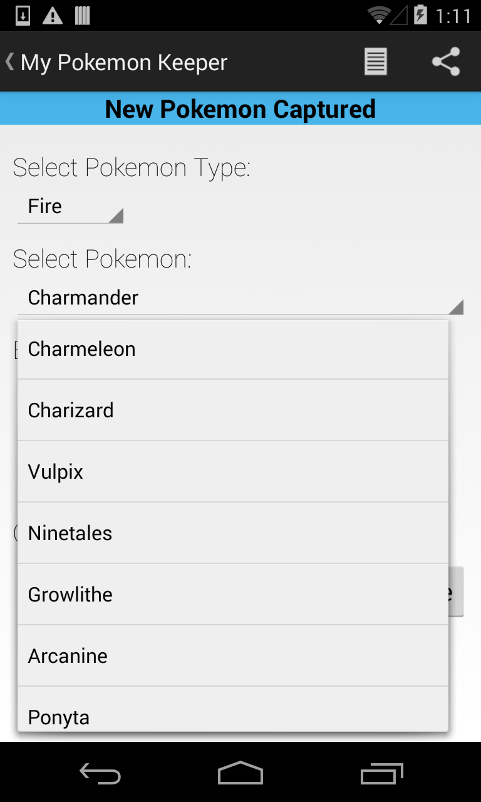

10

7

2

Read JSON Function

2

Custom Spinner Adapter

1

Spinner Adapter

Progression Summary



Visual Progression (if applicable)

Fill out one form per feature (not activity). In the Visual Progress pane, try and outline any progress you will have made to features that affect the visual display of the app - UI Views, Navigation Controls, etc. Don’t show the entire screen (unless applicable), concentrate on the feature.

Expected Functionality



The user will be able to select a Pokémon type from the first spinner, which will query the data to the second spinner. The user will be able to select the Pokémon from the second spinner. The Pokémon data will be read from a JSON formatted file.

Details & Status

AddNew

Spinners

0

Activity

Feature

Est. Hours

Completed

0

Actual

12/11/2013

Hours

Hours

Hours

Hours

Component

Component

Component

Component

Components

Changes & Outcomes



Finding a way to display the data quickly was a major challenge. I decided to display a progress dialog to notify the user that the application is gathering data. I also used an AsyncTask to get the JSON data.

Spinners

2



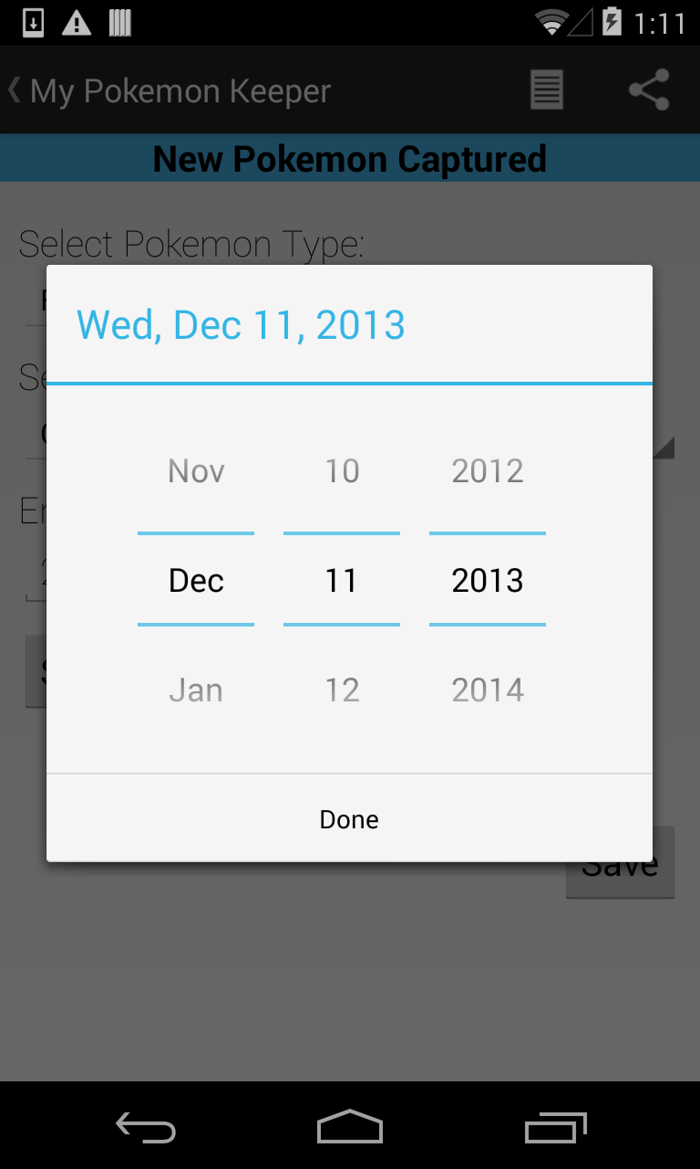

2

1

Progression Summary



Visual Progression (if applicable)

Fill out one form per feature (not activity). In the Visual Progress pane, try and outline any progress you will have made to features that affect the visual display of the app - UI Views, Navigation Controls, etc. Don’t show the entire screen (unless applicable), concentrate on the feature.

Expected Functionality



The user will be able to press the “Select a Date” button, which will display the date picker. Once the user selects the date and hits the “Done” button, it will display the date the Pokémon was caught.

Details & Status

AddNew

DatePicker

0

Activity

Feature

Est. Hours

Completed

0

Actual

12/09/2013

Hours

Hours

Hours

Hours

Component

Component

Component

Component

Components

Changes & Outcomes



The only issue I had had with the date picker was the month would not display properly. A new function was created to display the full month name.

DatePicker Function

1